

**UNIVERSITY OF PETROLEUM AND ENERGY STUDIES**

**School of Computer** **Science**

**2020-21**

**GRAPHICS AND ANIMATION TOOLS LAB**

**Faculty: Dr. DURGANSH SHARMA**

**Assistant Professor**

**Department of Cybernetics.**

**School of Computer Science, UPES**

**Submitted By:**

**Name- Garima Dhall**

**Roll no-R100217025**

**Batch-B1**

**Semester- 7**

**Course-B.tech. CSE-OSOS**

**Sap Id- 500062498**

**EXPERIMENT NO 1**

**Aim** :- Installation of GIMP and BLENDER

**Objective** :- To install and configure GIMP and BLENDER tool on different operating systems.

**STEPS TO INSTALL GIMP :-**

1. Visit the link <https://www.gimp.org/> to download the latest version of the GIMP ( GNU Image Manipulation Program ) GIMP is a cross-platform image editor available for GNU/Linux, OS X, Windows and more operating systems. It is [free software](https://www.gnu.org/philosophy/free-sw.html), you can change its [source code](https://git.gnome.org/browse/gimp) and [distribute](https://www.gnu.org/licenses/quick-guide-gplv3.en.html) your changes.

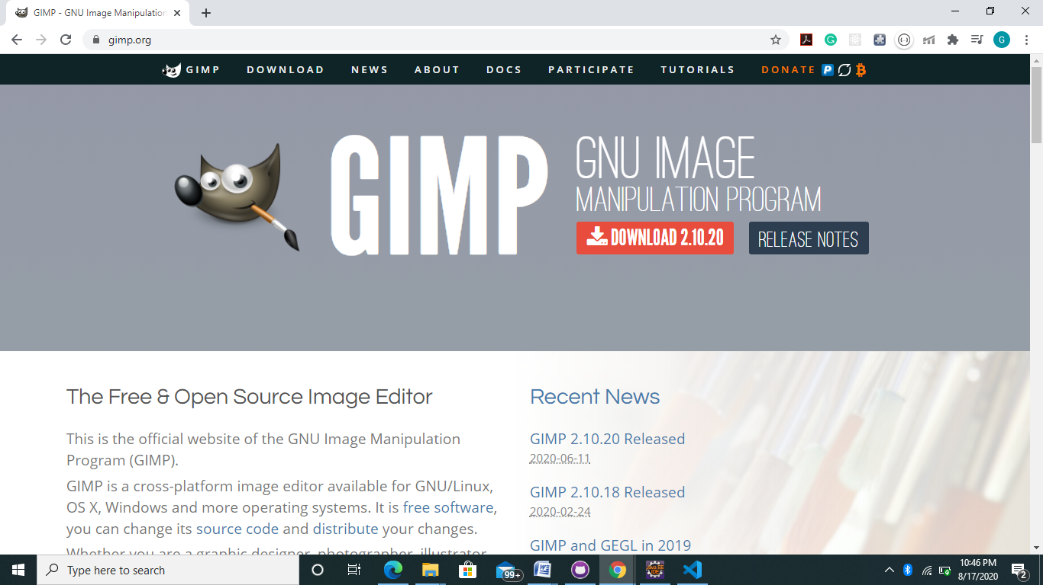

1. After the above screen appear click on the download button to download the latest version of GIMP ( the latest version of GIMP tool is 2.10.20 ) . After downloading the below screen will appear

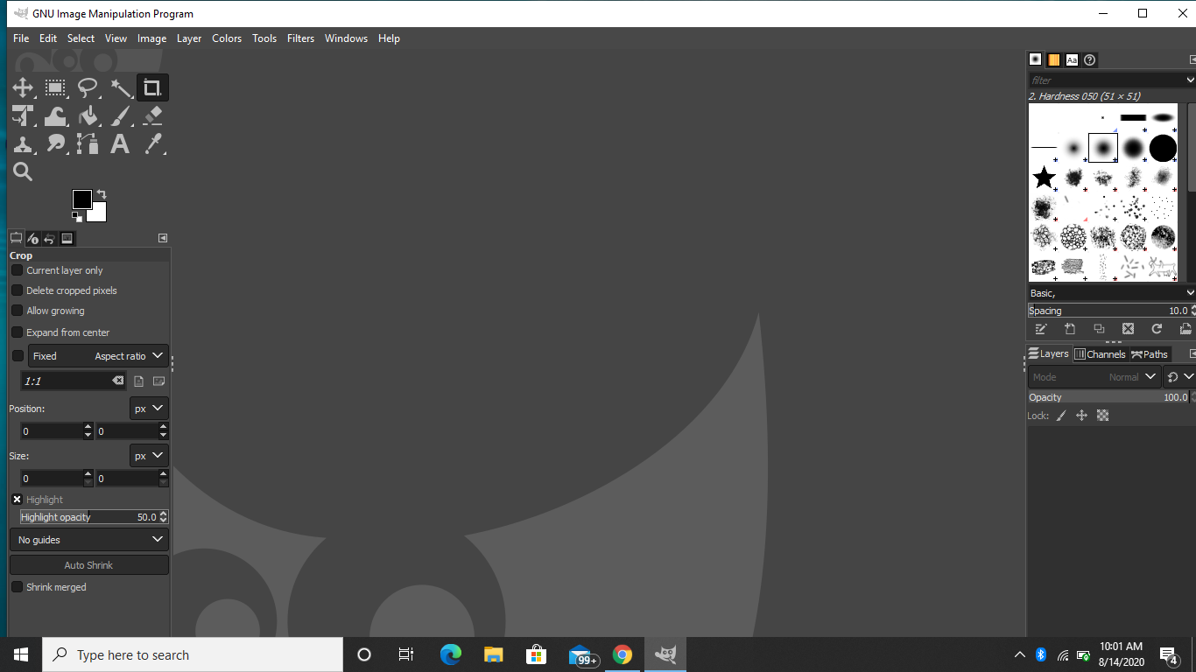

**STEPS TO INSTALL BLENDER:-**

1. Visit the link to download the latest version of the blender . Blender is the free and open source 3D creation suite. It supports the entirety of the 3D pipeline—modeling, rigging, animation, simulation, rendering, compositing and motion tracking, video editing and 2D animation pipeline.

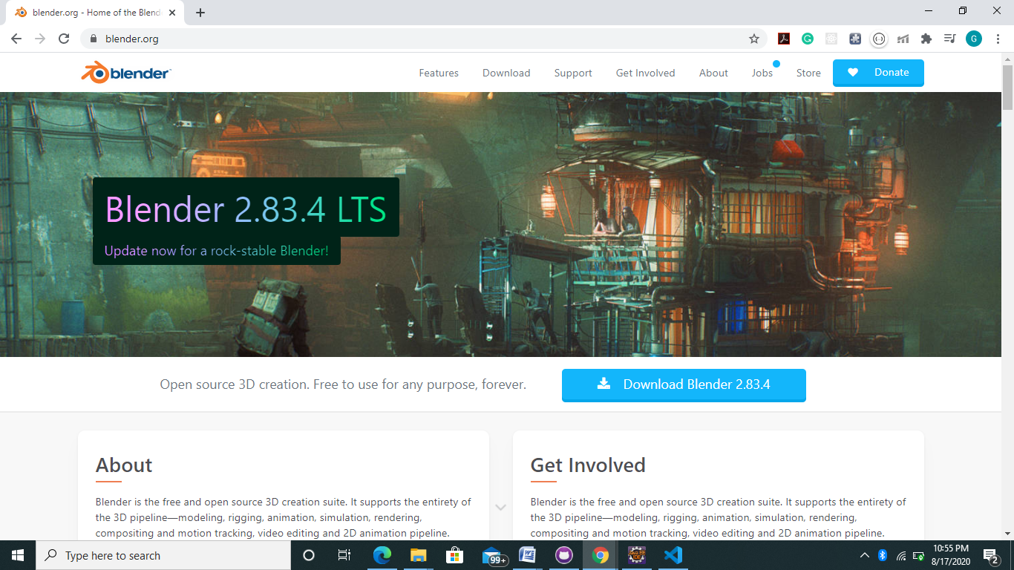

1. After the above screen appears click on the download button to download the latest version of BLENDER (the latest version of the BLENDER is 2.83.4) .After download the below screen will appear

